- Create a smoke test checklist for the login and dashboard features of a food delivery app like Zomato, listing at least 5 key test cases that would quickly verify if the main flows work after a new build.
Ans=>
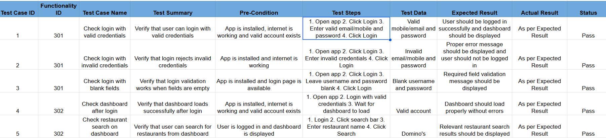

- Write a sanity test scenario for the 'Add to Cart' feature in a Flipkart-style shopping app, focusing only on verifying a recent bug fix without retesting unrelated functionality.<br><br><em><strong>Hint:</strong> Your scenario should be limited to confirming the specific fix works as expected.</em>
Ans=> Scenario: Verify the recent Add to Cart bug fix.
Precondition: The affected product and bug-fix build are available.
Steps:
- Open the affected product.
- Click Add to Cart once.
- Open the cart.
- Verify the affected product is present in the cart with the expected quantity of 1.
Expected Result: The specific issue addressed by the recent fix is resolved, and the product is successfully added to the cart as expected.
Scope: Do not retest unrelated cart, checkout, payment, search, or product functionality.

- Compare smoke testing and sanity testing by creating a table with at least 4 differences, using examples from popular apps like Instagram or Paytm to illustrate each point.
Ans=>
Example – Paytm | After a major Paytm release, verify that login, balance display, UPI payments, and transaction history are accessible. | If a fix addresses UPI payment confirmation not appearing, verify that confirmation now appears correctly without retesting the entire payment ecosystem.
Decision after testing | If smoke testing fails, the build is generally considered unstable and further testing may stop. | If sanity testing fails, the specific fix/change is rejected for further correction.
Testing approach | Often based on a predefined set of critical test cases. | Often uses targeted test cases around the affected area.
Main question | “Is this build stable enough to test further?” | “Did this specific change or fix work as expected?”

- Given this situation: After a major update, the Spotify app crashes on startup for some users. Decide whether smoke testing or sanity testing is appropriate first, and explain your reasoning in 2-3 lines.

Ans=> Smoke testing is appropriate first because the crash on startup is a critical, broad-impact issue that may make the entire app unusable.
Smoke testing can quickly determine whether the updated build is stable enough for further testing before focusing on specific fixes.

